## GLMER Prop ~ language * time_bin * trial_num * vocab + (trial_num | participant)

# 20 m PRE SWITCH

|  |  |  |  |
| --- | --- | --- | --- |
|  | **Prop** | | |
| *Predictors* | *Estimates* | *CI* | *p* |
| (Intercept) | 0.15 | 0.04 – 0.26 | **0.009** |
| language [Bilinguals] | -0.00 | -0.17 – 0.16 | 0.961 |
| vocab_centred | -0.00 | -0.00 – 0.00 | 0.709 |
| TimeBin | 0.18 | 0.15 – 0.22 | **<0.001** |
| trial_num_scaled | -0.02 | -0.04 – 0.01 | 0.158 |
| language [Bilinguals] * vocab_centred | -0.00 | -0.00 – 0.00 | 0.344 |
| language [Bilinguals] * TimeBin | -0.02 | -0.07 – 0.04 | 0.534 |
| vocab_centred * TimeBin | -0.00 | -0.00 – 0.00 | 0.466 |
| language [Bilinguals] * trial_num_scaled | 0.00 | -0.03 – 0.04 | 0.797 |
| vocab_centred * trial_num_scaled | 0.00 | -0.00 – 0.00 | 0.647 |
| TimeBin * trial_num_scaled | -0.00 | -0.01 – 0.01 | 0.737 |
| (language [Bilinguals] * vocab_centred) * TimeBin | 0.00 | -0.00 – 0.00 | 0.374 |
| (language [Bilinguals] * vocab_centred) * trial_num_scaled | 0.00 | -0.00 – 0.00 | 0.925 |
| (language [Bilinguals] * TimeBin) * trial_num_scaled | -0.00 | -0.02 – 0.01 | 0.582 |
| (vocab_centred * TimeBin) * trial_num_scaled | 0.00 | -0.00 – 0.00 | 0.505 |
| (language [Bilinguals] * vocab_centred * TimeBin) * trial_num_scaled | -0.00 | -0.00 – 0.00 | 0.217 |
| N recording_name | 38 | | |
| Observations | 1270 | | |
| Marginal R2 / Conditional R2 | 0.268 / 0.390 | | |

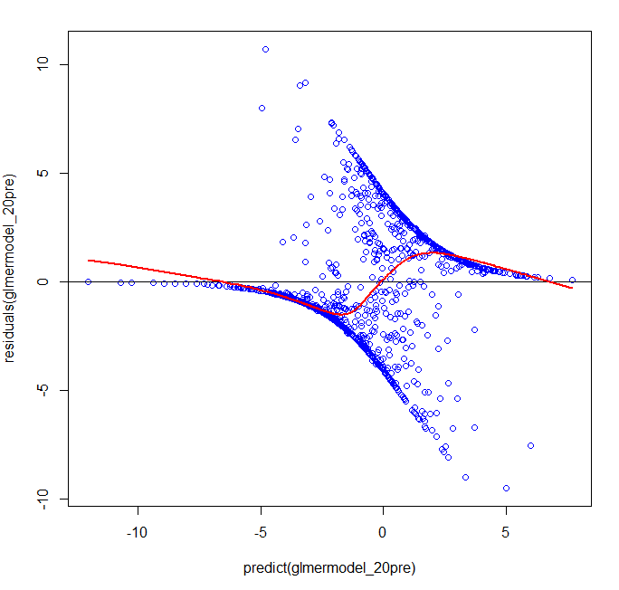

# 20 m POST SWITCH

|  |  |  |  |
| --- | --- | --- | --- |
|  | **Prop** | | |
| *Predictors* | *Estimates* | *CI* | *p* |
| (Intercept) | 0.18 | 0.06 – 0.30 | **0.003** |
| language [Bilinguals] | 0.17 | -0.00 – 0.35 | 0.052 |
| vocab_centred | -0.00 | -0.00 – 0.00 | 0.500 |
| TimeBin | 0.09 | 0.05 – 0.13 | **<0.001** |
| trial_num_scaled | -0.01 | -0.04 – 0.01 | 0.250 |
| language [Bilinguals] * vocab_centred | 0.00 | 0.00 – 0.01 | **0.005** |
| language [Bilinguals] * TimeBin | 0.02 | -0.03 – 0.08 | 0.424 |
| vocab_centred * TimeBin | 0.00 | -0.00 – 0.00 | 0.547 |
| language [Bilinguals] * trial_num_scaled | -0.03 | -0.06 – 0.01 | 0.147 |
| vocab_centred * trial_num_scaled | 0.00 | -0.00 – 0.00 | 0.678 |
| TimeBin * trial_num_scaled | 0.00 | -0.00 – 0.01 | 0.339 |
| (language [Bilinguals] * vocab_centred) * TimeBin | -0.00 | -0.00 – -0.00 | **0.049** |
| (language [Bilinguals] * vocab_centred) * trial_num_scaled | -0.00 | -0.00 – -0.00 | **0.019** |
| (language [Bilinguals] * TimeBin) * trial_num_scaled | -0.00 | -0.02 – 0.01 | 0.767 |
| (vocab_centred * TimeBin) * trial_num_scaled | 0.00 | -0.00 – 0.00 | 0.956 |
| (language [Bilinguals] * vocab_centred * TimeBin) * trial_num_scaled | -0.00 | -0.00 – 0.00 | 0.671 |
| N recording_name | 38 | | |
| Observations | 1184 | | |
| Marginal R2 / Conditional R2 | 0.185 / 0.296 | | |

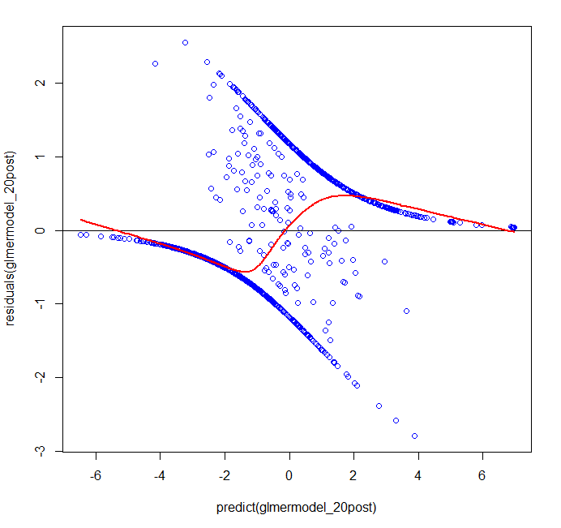

# 7 m PRE SWITCH

|  |  |  |  |
| --- | --- | --- | --- |
|  | **cbind(Samples In AOI/Samples Total)** | | |
| *Predictors* | *Odds Ratios* | *CI* | *p* |
| (Intercept) | 0.00 | 0.00 – 0.01 | **<0.001** |
| language [Bilinguals] | 0.69 | 0.04 – 12.29 | 0.804 |
| TimeBin | 7.66 | 6.46 – 9.08 | **<0.001** |
| trial_num_scaled | 1.40 | 0.96 – 2.03 | 0.082 |
| language [Bilinguals] * TimeBin | 0.43 | 0.34 – 0.53 | **<0.001** |
| language [Bilinguals] * trial_num_scaled | 1.11 | 0.65 – 1.88 | 0.704 |
| TimeBin * trial_num_scaled | 0.90 | 0.86 – 0.93 | **<0.001** |
| (language [Bilinguals] * TimeBin) * trial_num_scaled | 1.13 | 1.08 – 1.19 | **<0.001** |
| N recording_name | 43 | | |
| Observations | 1436 | | |
| Marginal R2 / Conditional R2 | 0.216 / 0.8634 | | |

# 

# 7 m POST SWITCH

|  |  |  |  |
| --- | --- | --- | --- |
|  | **cbind(Samples In AOI/Samples Total)** | | |
| *Predictors* | *Odds Ratios* | *CI* | *p* |
| (Intercept) | 0.00 | 0.00 – 0.02 | **<0.001** |
| language [Bilinguals] | 0.31 | 0.01 – 12.16 | 0.531 |
| TimeBin | 1.23 | 1.07 – 1.41 | **0.003** |
| trial_num_scaled | 1.10 | 0.70 – 1.73 | 0.673 |
| language [Bilinguals] * TimeBin | 2.74 | 2.22 – 3.37 | **<0.001** |
| language [Bilinguals] * trial_num_scaled | 1.24 | 0.73 – 2.09 | 0.426 |
| TimeBin * trial_num_scaled | 1.06 | 1.02 – 1.09 | **0.001** |
| (language [Bilinguals] * TimeBin) * trial_num_scaled | 0.97 | 0.93 – 1.02 | 0.296 |
| N recording_name | 43 | | |
| Observations | 1383 | | |
| Marginal R2 / Conditional R2 | 0.109 / 0.873 | | |

## GLMER Prop ~ language * time_bin * trial_num * vocab + (1 | participant)

# 7 m PRE SWITCH

|  |  |  |  |
| --- | --- | --- | --- |
|  | **cbind(Samples In AOI/Samples Total)** | | |
| *Predictors* | *Odds Ratios* | *CI* | *p* |
| (Intercept) | 0.00 | 0.00 – 0.01 | **<0.001** |
| language [Bilinguals] | 2.09 | 0.38 – 11.59 | 0.398 |
| TimeBin | 6.47 | 5.67 – 7.40 | **<0.001** |
| trial_num_scaled | 1.35 | 1.25 – 1.45 | **<0.001** |
| language [Bilinguals] * TimeBin | 0.43 | 0.36 – 0.51 | **<0.001** |
| language [Bilinguals] * trial_num_scaled | 0.85 | 0.77 – 0.94 | **0.002** |
| TimeBin * trial_num_scaled | 0.91 | 0.89 – 0.94 | **<0.001** |
| (language [Bilinguals] * TimeBin) * trial_num_scaled | 1.11 | 1.07 – 1.15 | **<0.001** |
| N recording_name | 43 | | |
| Observations | 1436 | | |
| Marginal R2 / Conditional R2 | 0.267 / 0.772 | | |

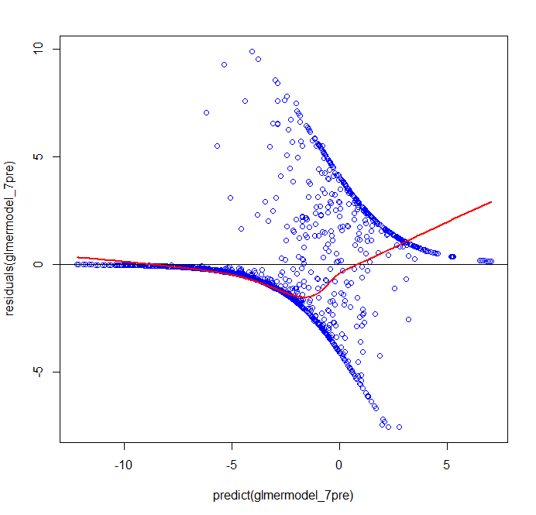

# 7 m POST SWITCH

|  |  |  |  |
| --- | --- | --- | --- |
|  | **cbind(Samples In AOI/Samples Total)** | | |
| *Predictors* | *Odds Ratios* | *CI* | *p* |
| (Intercept) | 0.00 | 0.00 – 0.02 | **<0.001** |
| language [Bilinguals] | 0.33 | 0.04 – 3.01 | 0.326 |
| TimeBin | 1.26 | 1.11 – 1.42 | **<0.001** |
| trial_num_scaled | 0.94 | 0.86 – 1.03 | 0.175 |
| language [Bilinguals] * TimeBin | 2.47 | 2.05 – 2.98 | **<0.001** |
| language [Bilinguals] * trial_num_scaled | 1.23 | 1.09 – 1.39 | **0.001** |
| TimeBin * trial_num_scaled | 1.05 | 1.02 – 1.09 | **0.001** |
| (language [Bilinguals] * TimeBin) * trial_num_scaled | 0.95 | 0.91 – 1.00 | **0.033** |
| N recording_name | 43 | | |
| Observations | 1383 | | |
| Marginal R2 / Conditional R2 | 0.108 / 0.807 | | |

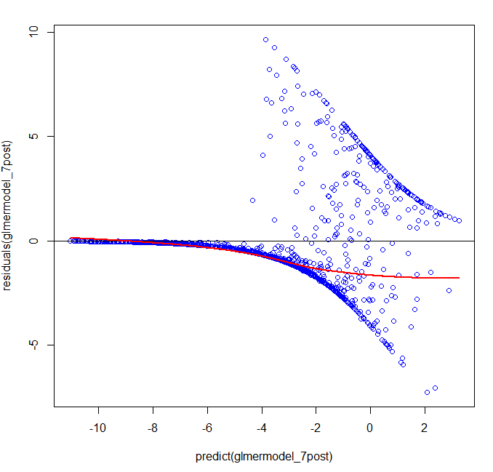

# 20 m: doesn’t converge for either